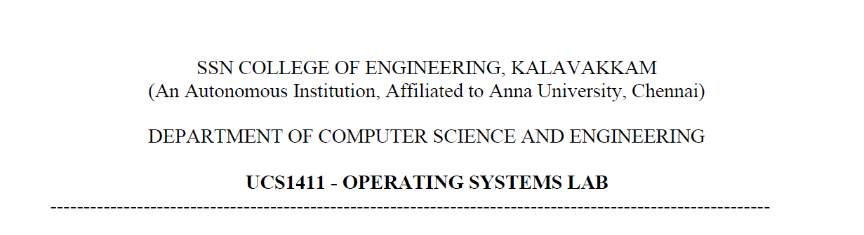

**LAB EXERCISE 3**

**Implementation of CPU Scheduling Policies**

**Submission Date:23-03-2022**

Name: Jayannthan P T

Dept: CSE ‘A’

Roll No.: 205001049

Develop a menu driven C program to implement the CPU Scheduling Algorithms FCFS and SJF

**Algorithm for FCFS:**

1. Get total no of process from the user.
2. Get process id, arrival time, burst time for all process.
3. Sort the process based on arrival time.
4. Loop until all process ends
   1. Set waiting time of process as sum of previous process waiting time and burst time by subtracting arrival time of the process
   2. Add current waiting time to total waiting time
   3. Set turnaround time of process as sum of waiting time and burst time
   4. Add current turnaround time to total turnaround time
5. Calculate average waiting time by dividing total waiting time by total no of process
6. Calculate average turnaround time by dividing total turnaround time by total no of process
7. Print process table
8. Print Gantt Chart

**Algorithm for SJF - Non-Preemptive:**

1. Get total no of process from the user.
2. Get process id, burst time for all process.
3. Sort the process based on burst time.
4. Loop until all process ends
   1. Set waiting time of process as sum of previous process waiting time and burst time by subtracting arrival time of the process
   2. Add current waiting time to total waiting time
   3. Set turnaround time of process as sum of waiting time and burst time
   4. Add current turnaround time to total turnaround time
5. Calculate average waiting time by dividing total waiting time by total no of process
6. Calculate average turnaround time by dividing total turnaround time by total no of process
7. Print process table
8. Print Gantt Chart

**Code:**

*/*Algorithm: 1. Read the following a. Number of processes b. Process IDs c. Arrival time for each process d. Burst Time for each process 2. Design a menu with FCFSand SJFoptions 3. Upon selection of menu option apply the corresponding algorithm. 4. Compute the Turnaround Time, Average waiting Time for each of the algorithm. 5. Tabularize the results. 6. Display the Gantt Chart.*/*

#include <stdio.h>

#include <stdlib.h>

#include <unistd.h>

#include <fcntl.h>

#include <string.h>

#include <dirent.h>

#include <ctype.h>

typedef **struct** process

{

**char** pid[3];

**int** arrival, burst, turnaround, waiting, completion;

} process;

**void** print_gantt_chart(process p**[]**, **int** n)

{

    printf("\n\nGantt-Chart\n");

**int** i, j;

    printf(" ");

    for (i = 0; i < n; i++)

    {

        for (j = 0; j < p[i].burst; j++)

            printf("--");

        printf(" ");

    }

    printf("\n|");

    for (i = 0; i < n; i++)

    {

        for (j = 0; j < p[i].burst - 1; j++)

            printf(" ");

        printf(" %s", p[i].pid);

        for (j = 0; j < p[i].burst - 1; j++)

            printf(" ");

        printf("|");

    }

    printf("\n ");

    for (i = 0; i < n; i++)

    {

        for (j = 0; j < p[i].burst; j++)

            printf("--");

        printf(" ");

    }

    printf("\n");

    printf("0");

    for (i = 0; i < n; i++)

    {

        for (j = 0; j < p[i].burst; j++)

            printf("  ");

        if (p[i].turnaround > 9)

            printf("\b");

        printf("%d", p[i].turnaround);

    }

    printf("\n");

}

**int** main()

{

**int** no_of_process;

**int** totalwaitingtime = 0, totalturnaround = 0;

**int** pos;

**char** ch = 'y';

    process p[100];

    while (ch == 'y' || ch == 'Y')

    {

**int** choice;

        printf("\nMenu\n\t1.FCFS\n\t2.SJF-Non Preemptive\n\t3.SJF-Preemptive\nEnter Choice:");

        scanf(" %d", &choice);

        switch (choice)

        {

        case 1:

        {

            printf("\nFCFS\n");

**int** no_of_process;

            printf("\nNumber of Processes :");

            scanf(" %d", &no_of_process);

            for (**int** i = 0; i < no_of_process; i++)

            {

                printf("\n\nProcess %d\n", i + 1);

                printf("Process ID: ");

                scanf(" %s", p[i].pid);

                printf("Arrival Time :");

                scanf(" %d", &p[i].arrival);

                printf("Burst Time :");

                scanf(" %d", &p[i].burst);

            }

            process temppro;

            for (**int** i = 0; i < no_of_process; i++)

            {

                pos = i;

                for (**int** j = i + 1; j < no_of_process; j++)

                {

                    if (p[j].arrival < p[pos].arrival)

                        pos = j;

                }

                temppro = p[i];

                p[i] = p[pos];

                p[pos] = temppro;

            }

            totalwaitingtime = 0, totalturnaround = 0;

            p[0].waiting = 0;

            p[0].turnaround = p[0].burst;

            totalturnaround += p[0].turnaround;

            for (**int** i = 1; i < no_of_process; i++)

            {

                if (p[i - 1].waiting + p[i - 1].burst - p[i].arrival > 0)

                {

                    p[i].waiting = p[i - 1].waiting + p[i - 1].burst - p[i].arrival;

                }

                else

                {

                    p[i].waiting = 0;

                }

                totalwaitingtime += p[i].waiting;

                p[i].turnaround = p[i].burst + p[i].waiting;

                totalturnaround += p[i].turnaround;

            }

            printf("\nP_ID\tArrival Time\tBurst Time\tTurnaround Time\t\tWaiting Time\n");

            for (**int** i = 0; i < no_of_process; i++)

            {

                printf("%s\t\t%d\t\t%d\t\t%d\t\t\t%d\n", p[i].pid, p[i].arrival, p[i].burst, p[i].turnaround, p[i].waiting);

            }

**float** avgwaiting = (**float**)(totalwaitingtime / no_of_process);

**float** avgturnaround = (**float**)(totalturnaround / no_of_process);

            printf("\n\t\tAVERAGE  AverageTurnaroundTime=%.2f\tAverageWaitingTime=%.2f\n", avgturnaround, avgwaiting);

            print_gantt_chart(p, no_of_process);

            break;

        }

        case 2:

        {

            printf("\nSJF-Non Preemptive\n");

**int** no_of_process;

            printf("\nNumber of Processes :");

            scanf(" %d", &no_of_process);

**int** totalwaitingtime = 0, totalturnaround = 0;

**char** pid[no_of_process][5];

            for (**int** i = 0; i < no_of_process; i++)

            {

                printf("\n\nProcess %d\n", i + 1);

                printf("Process ID: ");

                scanf(" %s", p[i].pid);

*// printf("Arrival Time :");*

                p[i].arrival = 0;

                printf("Burst Time :");

                scanf(" %d", &p[i].burst);

            }

            process temppro;

            for (**int** i = 0; i < no_of_process; i++)

            {

                pos = i;

                for (**int** j = i + 1; j < no_of_process; j++)

                {

                    if ((p[j].arrival < p[pos].arrival) || ((p[j].arrival <= p[pos].arrival) && (p[j].burst < p[pos].burst)))

                    {

                        pos = j;

                    }

                }

                temppro = p[i];

                p[i] = p[pos];

                p[pos] = temppro;

            }

            totalwaitingtime = 0, totalturnaround = 0;

            p[0].waiting = 0;

            p[0].turnaround = p[0].burst;

            totalturnaround += p[0].turnaround;

            for (**int** i = 1; i < no_of_process; i++)

            {

                if (p[i - 1].waiting + p[i - 1].burst - p[i].arrival > 0)

                {

                    p[i].waiting = p[i - 1].waiting + p[i - 1].burst - p[i].arrival;

                }

                else

                {

                    p[i].waiting = 0;

                }

                totalwaitingtime += p[i].waiting;

                p[i].turnaround = p[i].burst + p[i].waiting;

                totalturnaround += p[i].turnaround;

            }

            printf("\nP_IDs\tBurst Time\tTurnaround Time\t\tWaiting Time\n");

            for (**int** i = 0; i < no_of_process; i++)

            {

                printf("%s\t\t%d\t\t%d\t\t\t%d\n", p[i].pid, p[i].burst, p[i].turnaround, p[i].waiting);

            }

**float** avgwaiting = (**float**)(totalwaitingtime / no_of_process);

**float** avgturnaround = (**float**)(totalturnaround / no_of_process);

            printf("\n\t\tAVERAGE  AverageTurnaroundTime=%.2f\tAverageWaitingTime=%.2f\n", avgturnaround, avgwaiting);

            print_gantt_chart(p, no_of_process);

            break;

        }

        case 3:

        {

            printf("\nSJF - Preemptive\n");

**int** no_of_process;

            printf("\nNumber of Processes :");

            scanf(" %d", &no_of_process);

            for (**int** i = 0; i < no_of_process; i++)

            {

                printf("\n\nProcess %d\n", i + 1);

                printf("Process ID: ");

                scanf(" %s", p[i].pid);

                printf("Arrival Time :");

                scanf(" %d", &p[i].arrival);

                printf("Burst Time :");

                scanf(" %d", &p[i].burst);

            }

            process temppro;

            for (**int** i = 0; i < no_of_process; i++)

            {

                pos = i;

                for (**int** j = i + 1; j < no_of_process; j++)

                {

                    if (p[j].arrival < p[pos].arrival)

                        pos = j;

                }

                temppro = p[i];

                p[i] = p[pos];

                p[pos] = temppro;

            }

**int** rem_time[no_of_process];

            for (**int** i = 0; i < no_of_process; i++)

            {

                rem_time[i] = p[i].burst;

            }

            for (**int** cur_time = 0, completed = 0; completed < no_of_process; cur_time++)

            {

**int** idx = -1;

                for (**int** i = 0; i < no_of_process; i++)

                {

                    if (p[i].arrival <= cur_time && rem_time[i] > 0 && (idx == -1 || rem_time[i] < rem_time[idx]))

                    {

                        idx = i;

                    }

                }

                if (idx != -1)

                {

                    rem_time[idx]--;

                    if (rem_time[idx] == 0)

                    {

                        completed++;

                        p[idx].completion = cur_time;

                        p[idx].turnaround = p[idx].completion - p[idx].arrival + 1;

                        p[idx].waiting = p[idx].turnaround - p[idx].burst;

                    }

                }

            }

            for (**int** i = 0; i < no_of_process; i++)

            {

*//  p[i].turnaround=p[i].burst+p[i].waiting;*

                totalwaitingtime += p[i].waiting;

                totalturnaround += p[i].turnaround;

            }

            printf("\nP_ID\tArrival Time\tBurst Time\tTurnaround Time\t\tWaiting Time\n");

            for (**int** i = 0; i < no_of_process; i++)

            {

                printf("%s\t\t%d\t\t%d\t\t%d\t\t\t%d\n", p[i].pid, p[i].arrival, p[i].burst, p[i].turnaround, p[i].waiting);

            }

**float** avgwaiting = (**float**)(totalwaitingtime / no_of_process);

**float** avgturnaround = (**float**)(totalturnaround / no_of_process);

            printf("\n\t\tAVERAGE  AverageTurnaroundTime=%.2f\tAverageWaitingTime=%.2f\n", avgturnaround, avgwaiting);

            print_gantt_chart(p, no_of_process);

            break;

        }

        case 4:

            printf("Exiting...");

            return 0;

        }

        printf("\nWant to Continue (Y/N):");

        scanf(" %c", &ch);

    }

    return 0;

}

**Output:**

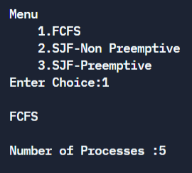 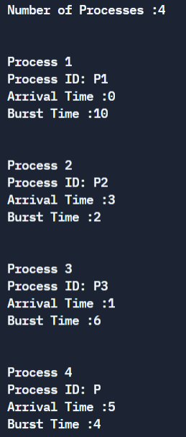

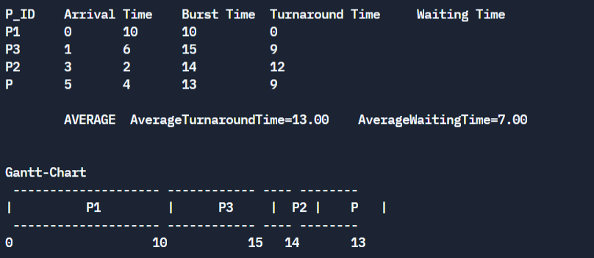

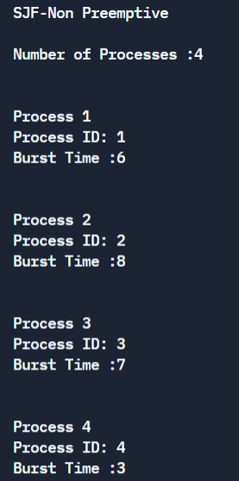 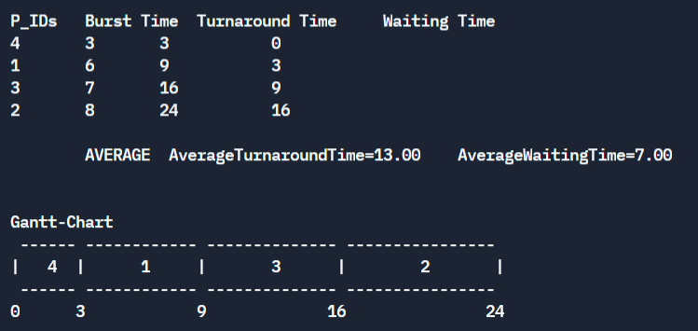

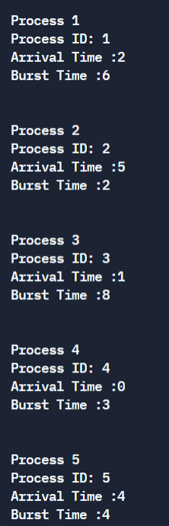 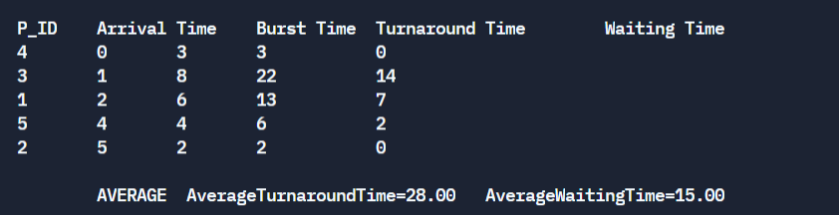

**Learning Outcome:**

* Implemented FCFS Scheduling and SJF Scheduling in C program
* Displayed Gantt Chart for the above scheduling methods